FB50 - General Ledger Invoice
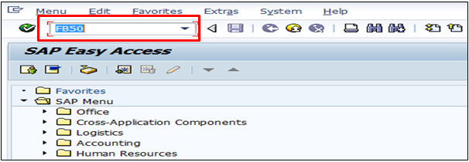
- Input FB50 in Transaction box and press Enter key

Document Header Data Information
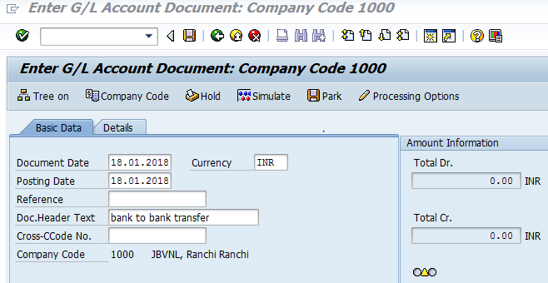
The following are the Input fields under the Document Header data
- Document Date: Input the Invoice date in the Document date field
- Posting Date: Input the transaction date in the Posting date field
- Currency: Input the Currency INR in the Currency field
- Reference: Input the Reference field with Reference (invoice) number
- Document Header Text: Input the Text Information in text field

Document Line Item Data
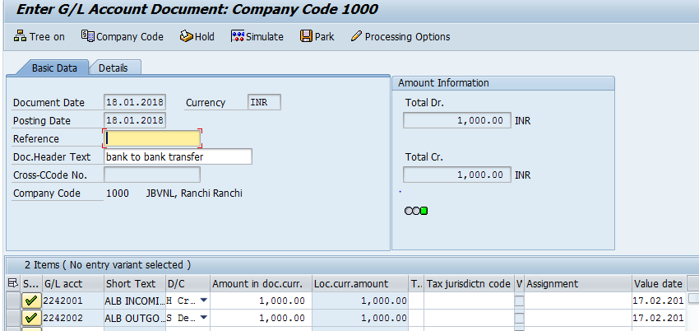
The following are the Input fields under the Line Item data
- GL Account: Place the Cursor on the field and press F4. Select the respective GL Account and press Enter key
- Debit/Credit: Select Debit/Credit option from drop down list
- Text Field: Input the Text information Eg: Expense Invoice
- Cost Center: Place the cursor on the field and press F4. Select the respective Cost Center and press Enter key
- Profit Center: Profit Center will get automatically updated (through Cost Center Profit Center will get updated) as configured.

Simulate
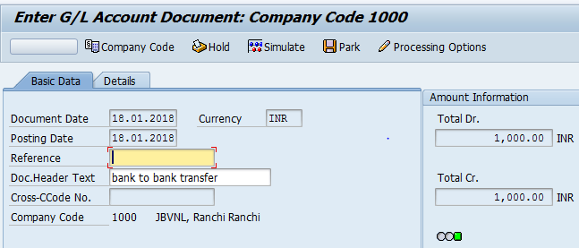
Simulate: Click on Simulate option. System will display the line items (Debit and Credit entry).
- Check the entries, if the entries are correct, click on Post option
- If the entries are wrong then go to Main screen and change the line items.
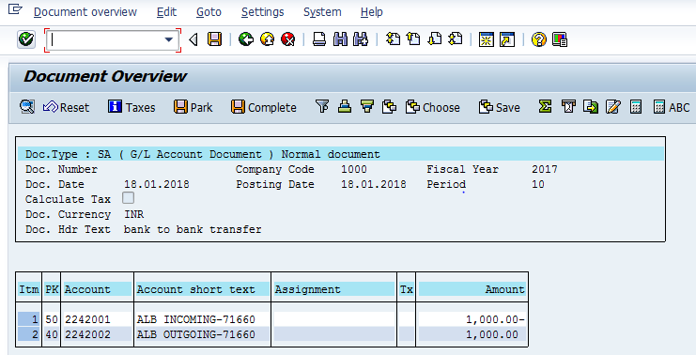

Document Posting
- Document Posted in company code 1000 will pop up at the bottom of the screen

Document Display View
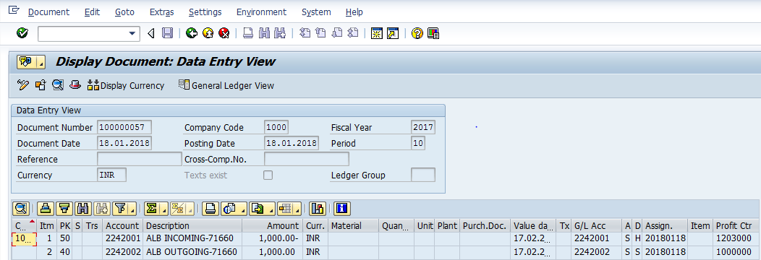
We can view the transaction in two ways:
- Display Document: From Menu bar select Document option it will display the options Change, Display, Post and Save as completed. Choose Display option. Document successfully got posted will get displayed
- Input FB03 in Transaction box and system will take us to Document Display screen. Input the Document number and Press Enter key. Document posted will get displayed.

Manual End

